**BANK LOAN REPORT QUERY DOCUMENT**

1. **BANK LOAN REPORT | SUMMARY**

**KPI’s:**

**Total Loan Applications:**

SELECT COUNT(id) AS Total_Applications FROM financial_loan;

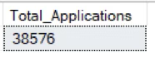

**MTD Loan Applications:**

SELECT COUNT(id) AS Total_Applications FROM financial_loan

WHERE MONTH(issue_date) = 12;

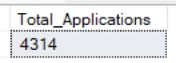

**PMTD Loan Applications:**  
 SELECT COUNT(id) AS Total_Applications FROM financial_loan

WHERE MONTH(issue_date) = 11;

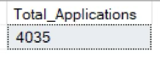

**Total Funded Amount:**

SELECT SUM(loan_amount) AS Total_Funded_Amount FROM financial_loan;

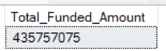

**MTD Total Funded Amount:**

SELECT SUM(loan_amount) AS Total_Funded_Amount FROM financial_loan

WHERE MONTH(issue_date) = 12;



**PMTD Total Funded Amount:**

SELECT SUM(loan_amount) AS Total_Funded_Amount FROM financial_loan

WHERE MONTH(issue_date) = 11;

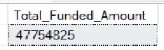

**Average Interest Rate:**

SELECT AVG(int_rate)*100 AS Avg_Int_Rate FROM bank_loan_data;

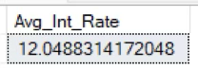

**MTD Average Interest:**

SELECT AVG(int_rate)*100 AS MTD_Avg_Int_Rate FROM bank_loan_data

WHERE MONTH(issue_date) = 12;

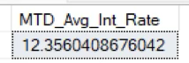

**PMTD Average Interest:**

SELECT AVG(int_rate)*100 AS PMTD_Avg_Int_Rate FROM bank_loan_data

WHERE MONTH(issue_date) = 11;

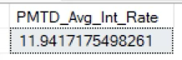

**Avg DTI:**

SELECT AVG(dti)*100 AS Avg_DTI FROM financial_loan;

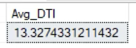

**MTD Avg DTI:**

SELECT AVG(dti)*100 AS MTD_Avg_DTI FROM financial_loan

WHERE MONTH(issue_date) = 12;

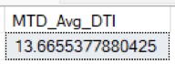

**PMTD Avg DTI:**

SELECT AVG(dti)*100 AS PMTD_Avg_DTI FROM financial_loan

WHERE MONTH(issue_date) = 11;

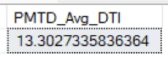

**GOOD LOAN ISSUED**

**Good Loan Percentage:**

SELECT

(COUNT(CASE WHEN loan_status = 'Fully Paid' OR loan_status = 'Current' THEN id END) * 100.0) /

COUNT(id) AS Good_Loan_Percentage

FROM financial_loan;

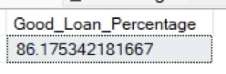

**Good Loan Applications:**

SELECT COUNT(id) AS Good_Loan_Applications FROM financial_loan

WHERE loan_status = 'Fully Paid' OR loan_status = 'Current';

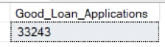

**Good Loan Funded Amount:**

SELECT SUM(loan_amount) AS Good_Loan_Funded_amount FROM financial_loan

WHERE loan_status = 'Fully Paid' OR loan_status = 'Current';

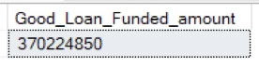

**Good Loan Amount Received:**

SELECT SUM(total_payment) AS Good_Loan_amount_received FROM financial_loan

WHERE loan_status = 'Fully Paid' OR loan_status = 'Current';

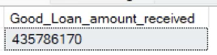

**BAD LOAN ISSUED**

**Bad Loan Percentage:**

SELECT

(COUNT(CASE WHEN loan_status = 'Charged Off' THEN id END) * 100.0) /

COUNT(id) AS Bad_Loan_Percentage;

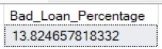

**Bad Loan Applications:**

SELECT COUNT(id) AS Bad_Loan_Applications FROM financila_loan

WHERE loan_status = 'Charged Off';

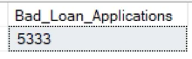

**Bad Loan Funded Amount**

SELECT SUM(loan_amount) AS Bad_Loan_Funded_amount FROM financila_loan

WHERE loan_status = 'Charged Off';

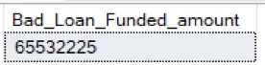

**Bad Loan Amount Received**

SELECT SUM(total_payment) AS Bad_Loan_amount_received FROM financila_loan

WHERE loan_status = 'Charged Off';

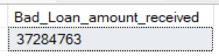

**LOAN STATUS**

SELECT

loan_status,

COUNT(id) AS LoanCount,

SUM(total_payment) AS Total_Amount_Received,

SUM(loan_amount) AS Total_Funded_Amount,

AVG(int_rate * 100) AS Interest_Rate,

AVG(dti * 100) AS DTI

FROM

Financial_loan

GROUP BY

loan_status;

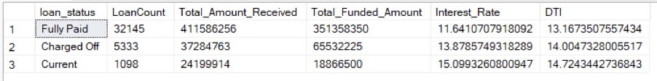

SELECT

loan_status,

SUM(total_payment) AS MTD_Total_Amount_Received,

SUM(loan_amount) AS MTD_Total_Funded_Amount

FROM financial_loan

WHERE MONTH(issue_date) = 12

GROUP BY loan_status;

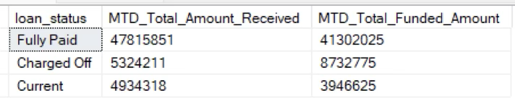

1. **BANK LOAN REPORT | OVERVIEW**

**MONTH**

SELECT

MONTH(issue_date) AS Month_Munber,

DATENAME(MONTH, issue_date) AS Month_name,

COUNT(id) AS Total_Loan_Applications,

SUM(loan_amount) AS Total_Funded_Amount,

SUM(total_payment) AS Total_Amount_Received

FROM financial_loan

GROUP BY MONTH(issue_date), DATENAME(MONTH, issue_date)

ORDER BY MONTH(issue_date);

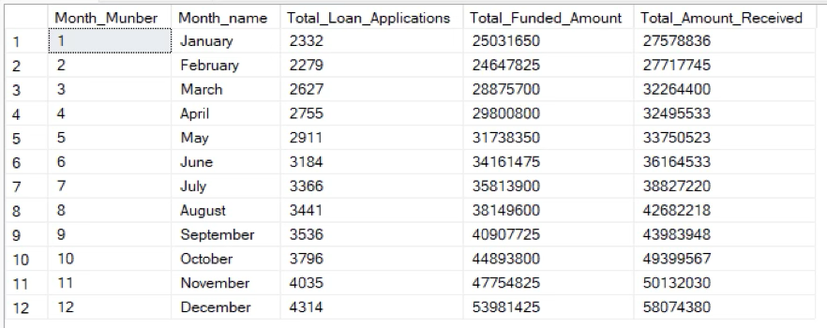

**STATE**

SELECT

address_state AS State,

COUNT(id) AS Total_Loan_Applications,

SUM(loan_amount) AS Total_Funded_Amount,

SUM(total_payment) AS Total_Amount_Received

FROM financila_loan

GROUP BY address_state

ORDER BY address_state;

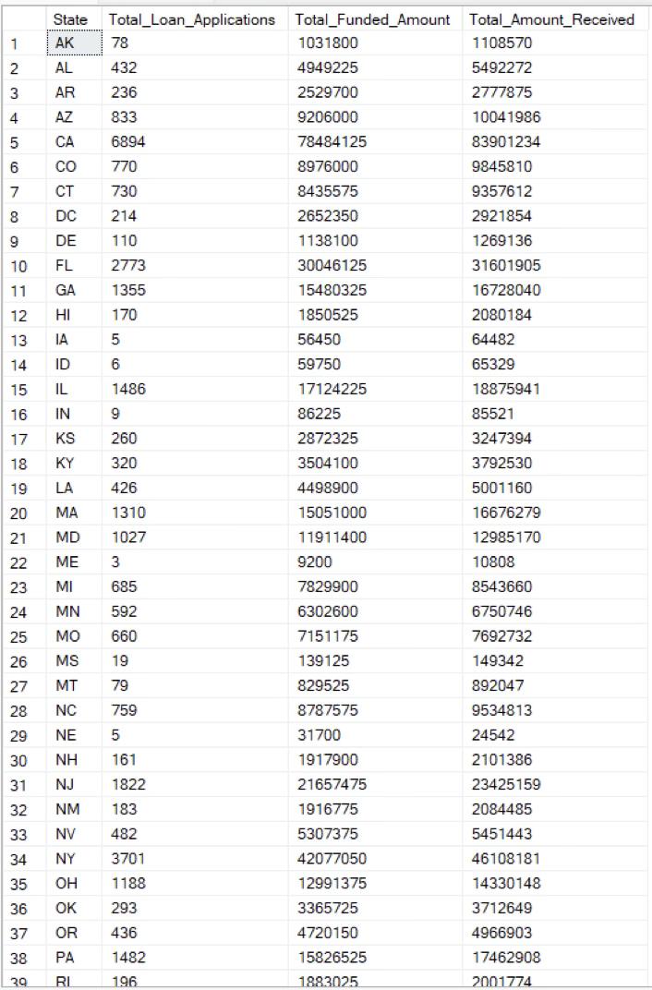

**TERM**

SELECT

term AS Term,

COUNT(id) AS Total_Loan_Applications,

SUM(loan_amount) AS Total_Funded_Amount,

SUM(total_payment) AS Total_Amount_Received

FROM financial_loan

GROUP BY term

ORDER BY term;

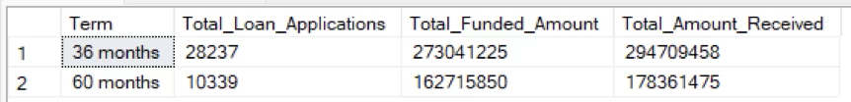

**EMPLOYEE LENGTH**

SELECT

emp_length AS Employee_Length,

COUNT(id) AS Total_Loan_Applications,

SUM(loan_amount) AS Total_Funded_Amount,

SUM(total_payment) AS Total_Amount_Received

FROM financial_loan

GROUP BY emp_length

ORDER BY emp_length;

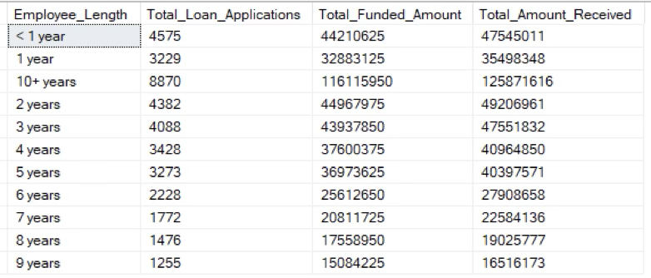

**PURPOSE**

SELECT

purpose AS PURPOSE,

COUNT(id) AS Total_Loan_Applications,

SUM(loan_amount) AS Total_Funded_Amount,

SUM(total_payment) AS Total_Amount_Received

FROM financial_loan

GROUP BY purpose

ORDER BY purpose;

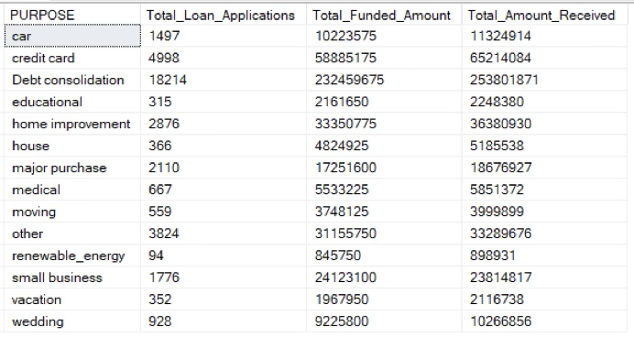

**HOME OWNERSHIP**

SELECT

home_ownership AS Home_Ownership,

COUNT(id) AS Total_Loan_Applications,

SUM(loan_amount) AS Total_Funded_Amount,

SUM(total_payment) AS Total_Amount_Received

FROM financial_loan

GROUP BY home_ownership

ORDER BY home_ownership;

